Report on the Activities Undertaken in the Project

Introduction
This report covers the activities undertaken in this project, which revolved around performing web crawling and scraping on a website in order to extract data on tennis players from articles on this site. The web crawling and web scraping procedures implemented in Task 1 and Task 2 will be examined followed by an analysis on the data visualizations generated in Task 4 and Task 5. This is followed by an assessment on the methods of extracting data from the articles including the tasks done in Task 2.

The Process of Web Crawling
The worldwide web can be envisioned as a graph where the nodes are the website and the URLs are the edges between them. This graph would be very large and highly complex with a considerable number of edges. A web crawler would start at a particular site (node) and traverse through the web (graph) via links (edges) to other sites (node) in order to create a database on them. The crawler would select a starting seed website and find all the links on it. The web crawler has lists V and U of visited and unvisited sites respectively to keep track of them. They add the new links to sites to U if they are not in V and the current site being explored is added to V. This is to ensure a site is not visited twice unnecessarily, however, some sites are revisited in order to keep an updated version of them. In this respect, the crawler will head through web and collect data on the inspected websites. This data is primarily URL links to other sites as crawlers main focus gravitates towards creating an indexing that allows these sites to be searched for in an efficient manner. Search engines have web crawlers for this purpose to give users faster and more relevant search results.

This mechanism was employed in Task 1 in order to develop a database of each unique article on the website and their respective URLs in the form of a CSV file. The process of web crawling through the links was done using the lists V and U as detailed above with any visited sites added to V. U was implemented as a queue where a first-in-first-out approach was used with new sites added to the end of U and websites to be inspected were taken from the start of U. For each article site, the next article and previous article links were followed and a site was only added to U if it was not in V and the article headline of that site had not been seen yet. Therein, a list of the headlines of visited articles was also maintained. As previously mentioned, the output of this operation was a CSV file with the headings “url” and “headline” where each row stores a URL and the headline for each article with the URL linking to the site that contains that article. A CSV file is a semi-structured data structure, where each line is like a row in a table and values are separated by commas like columns in a table. The first line are the headings and the remaining lines are data.

The Process of Web Scraping
Web scraping involves visiting a website and extracting data from that site. The site chosen and data searched for is more specifically defined in contrast to web crawling and several sites may be visited. In addition, web scraping is to a greater extent fixated on gathering data, whereas web scraping is more concentrated on going through links and indexing websites. This procedure was implemented in Task 2 of the project to gain further information from each article. This information was a player name and score. The player name is the first name in the article from a predefined list of names in the “tennis.json” file and the score is the first valid tennis score set for a game found in the article. It is presumed that the article is about that player and that the score is related to that player. After these details were acquired, they were appended to the data from the CSV file made in Task 1. This resulted in a new CSV file with the headings url, headline, player and score being created to store the new information. Each row contains information for an article, which is the URL to the site storing the article, the headline of the article, the player first mentioned in the article and the first valid score set found in the article. Furthermore, some articles lacked a player name from the list or a valid score set and those articles were discarded from the new CSV file. To procure the data each article was visited in turn by using the URL links stored in the CSV file from task 1 and their headline and body text was concatenated together as a long string. The headline was at the start and obtained from the CSV file from Task and obtaining the body text required understand the HTML structure of the articles and involved accessing the div tag with the id “articleDetail”. Under this tag, each paragraph was in a separate p tag and these had to be accessed and concatenated together.
To get the first player name a list of available player names from the “tennis.json” file was created and the capitalization of these names was also fixed. The string containing the headline and body text was then split into a list of individual words and matches between the list of available player names and these words were done. This revolved around checking if a word was a part of any name and the first matching name to a word was picked as the first name in the article and added to the output file. If no match was found, the article was discarded. Regular expressions were used to get the score data from the article by first using "(([, ][\d]{1,2}[-/][\d]{1,2})|([, ]\([\d]{1,2}[-/][\d]{1,2}\))){2,10}" to find the first potential complete score in the text based on the score formatting. This was checked against "(((0|15|30|45)-(0|15|30|45))|([0-5]-[0-5])|(6-[569])|([569]-6))$" to determine if it is valid in terms of scoring and number of matches. The next potential score was searched for in the event this score is not valid. This was done by removing the invalid score from the article text and performing the search again until no more matches occured. In this situation, the article was discarded. However, a valid score was cleaned and added to the output file. The discarding of articles with no valid name or score was accomplished by marking their values for these data points with “N\A” and any articles containing that in their player or score columns where not added to the final CSV file.

Description and Analysis of Compiled Data
In Task 4, the information in the output of Task 2 was utilized to find the number of times each player contained in the output of Task 2 was mentioned by an article. These are the tennis players that are assumed the articles are written about. This frequency was obtained by grouping each row of data in the Task 2 output CSV file by player name using the Pandas module and then tallying up the number of articles in each group. The players with the top five frequencies was then plotted on a bar chart (Figure 1) and ties in frequencies was handled by giving preference of players occurring in earlier rows in the CSV file output in Task 2. This is how Figure 1 was constructed, which shows the top five out of 32 players with the highest article coverage frequency. The output of Task 3 highlights that 32 players have at least one article about them.

In Figure 1, the data is discrete with the frequencies being ordinal data and the names being categorical data. The names are organized in descending frequencies from left to right with Andy Roddick having the highest coverage frequency of six and Greg Rusedski having the lowest among the five players, which was two. The range of frequencies is thus four with a mode of three, median of three and mean of 3.6 reflecting that the centre is around 3. Moreover, the standard deviation is 0.607 with the frequency distribution being left skewed and unimodal. In addition, one can compare Figure 1 to the frequency results of the other 27 tennis players, who all have either two or one frequency. This highlights that the majority of players have low article coverage with only a few having high article coverage, especially Andy Roddick.

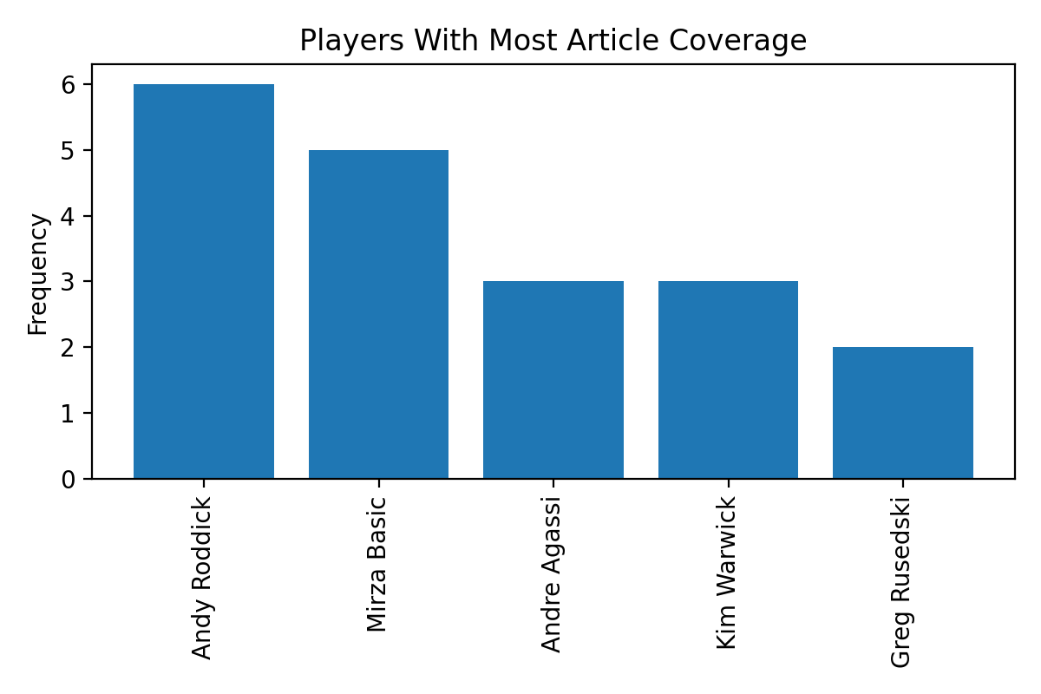
In Task 5, a figure (Figure 2) showing the win percentage and average game difference for each player was created, which are both continuous variables. The win percentage is obtained from the “tennis.json” file and the average game difference was calculated in Task 3. The average game difference was computed by grouping the scores for each player from the output CSV file from Task 2, calculating the game difference for each score and then the average for each tennis player. Tie breaker scores in brackets are ignored. This data was then formed into a scatter plot (Figure 2) with the x-axis showing average game difference and the y-axis displaying win percentage where each cross mark represents each individual player and the data for them. For Figure 2, a scatter plot was used instead of a bar chart due to the large number of players having information displayed about them would create clutter on the x-axis on a bar chart. Additionally, a scatter plot can illrustrate the relationship between average game difference and win percentage and among players to a greater degree. Therein, it is easier to understand the plot. However, the ability to view the data for a specific player is lost as a consequence.
Figure 1
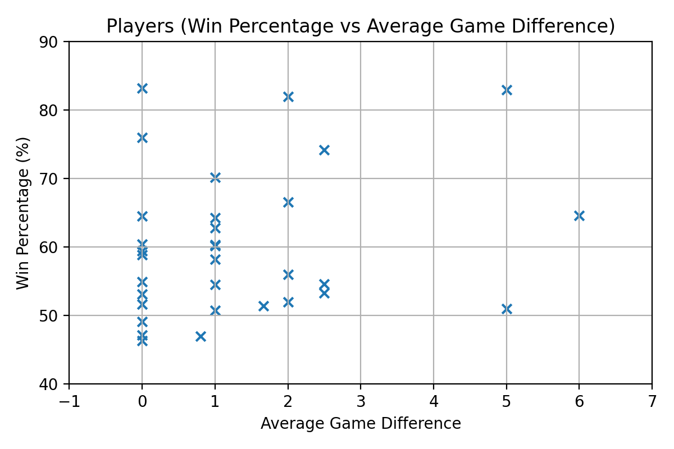
In Figure 2, the data points for the 32 players are split into two distinct clusters on the left and right side of the plot, which contain 29 and 3 points respectively. In addition, the points in the left cluster are concentrated between the win percentages of 45% to 65% and this is where most win percentages for the players lie. The most common average game differences are zero and one with zero being the lowest and six the highest. These have a distribution that is right skewed, which reflects how most data points cluster around the left side of the plot. Furthermore, the highest win percentage is around 83% and the lowest is around 46%. Given this one could make the following conclusions.
Figure 2

Firstly, the points in the right cluster may be considered outliers as they are very few relative to the left cluster. Given this one would focus on the left cluster and posit that most of the players that these articles have written about share similar characteristics in regards to their win percentage and average game difference, which indicate their performance level. This means most of these players win around half to a majority of their games and the games they play are close games where they win by a small margin. An explanation for this pattern might be that better players would likely receive more media coverage and thus Figure 2 is collecting data mostly from this type of player. This would indicate a bias towards high performing players in the data collection. Hence, one would need to collect information on other groups of players and add it to Figure 2 and that may result in an alternative spread of the data points. On the other hand, the clustering may be a consequence of potential inefficiencies in the method of collecting the data by associating the first name to the first valid complete score set. The appropriateness of this approach will be evaluated in the next section. Further, the right cluster may not be outliers as tennis is a situation where players deviating from the rest is likely considering the sport is very big. In this case, then the right cluster shows some players having large average game differences, where two of them have average win percentages, whilst the other one wins a large number of their games. This can explain their large average game difference as they may have a skill level far exceeding other tennis players. Lastly, the correlation strength between these two variables in regards to constructing a trend curve is none.

Discussion on Method of Associating Players and Scores
In Task 2, it was assumed that the first mentioned player in the article is associated with the first match score that appears. This could be based on the idea that the article is primarily about that individual, especially if their name is mentioned in the headline, and any scores in that article would pertain to that individual, particularly scores at the start of the article. This is due to the start of the article often being a hook line linked to the article’s main idea, which can be the first named player, to draw the reader in. In addition, a score closer to a name has a higher probability of being associated with it or when both are in the same sentence. Hence, this method of player and score association has some merit. However, the article can name several individuals and devote a considerable amount of the article to those other people as observed in the article “Big guns ease through in San Jose” where the first name is Andy Roddick, but Andre Agassi, Dane Kenneth Carlsen and Hyung-Taik Lee among others are also mentioned. This article also devotes a fair amount of time detailing the matches between some of these other individuals and this would reduce the value of this technique. However, these scores and details are generally found later in the article and this process reflects that situation giving it more credit. Albeit, the first few scores may be invalid and a score much later in the article may be linked to the first name when they are unlikely to be connected, although, this situation has a lessor chance of occurring. This slightly reduces the effectiveness of this method, which can be improved by taking this into account.
Moreover, this procedure fails to account when another name separates the first named player and the first score. In the “Big guns ease through in San Jose” article we see an illustration of this where Andre Agassi is mentioned after Andy Roddick at the start of the article and the following score is related to Roddick. Thus, the method of name and score association should take this into account to improve its appropriateness. Further, this method could be improved by instead looking for a sentence with their name or a pronoun related to them with a score and then associate them with that score. Nevertheless, several articles including “Federer wins title in Rotterdam”, “Mauresmo fights back to win title” and “Agassi into the second round in Dubai” demonstrate that this approach of associating the first name with the first score has a considerable degree of effectiveness. Therefore, this method has an extent of suitability for making accurate connections between players and scores, although, it can be improved to a considerable degree. This could be done by better handling the circumstances when the first few potential scores are invalid and another name separates the first name and the first valid score.

Determining if First Named Player Won or Lost Match Reported on
As the article can report on several matches, the first player name has to be associated with the right one. The first possible method to realize this is to look for sentences with that name and a score in it with that score likely to be affiliated to that name. The player can be referred to by their name or by a characteristic such as gender or nationality. When they are mentioned by a personal trait, a connection between their traits and that quality needs to be made and assessed if they are related. For example, their gender may be estimated by their name as certain names are more common for each gender. Moreover, their nationality and other qualities can be found in the “tennis.json” file. Once the association is made, one then needs to decide if the left or right number refers to the player. If their name/pronoun comes before the score or before another name, then they are linked to the left number and if their name comes after the score or another name, then they are connected to the right number. Once, this is completed, one needs to tally up the score set and determine if the first named player won that match or not.

A further operation is to look for name/pronoun pairs in a sentence where one of those names/pronouns are the first named player and looking for key words in between them such as “shocks”, “beats” or “wins” to determine which player won the match. This approach is quite applicable when applied in the headline such as in the article “Henman overcomes rival Rusedski”. This headline suggests that Tim Henman won a match against Greg Rusedski.

Ways to Determine Player Performance
In order to better understand player performance, an alteration to the two methods in the last section can be applied. It had been highlighted in the last section how two names/pronouns and a score can be related when in a sentence and how to determine who could of won that game. This can be applied to every pair in an article to create a database on player performance, which can likewise be implemented on the other technique in the preceding section, which is looking for names with key words between them to observe who won a game between them. Another technique is to find sentences with names/pronouns and key words that could potentially describe an achievement or statistic for that individual. These key words could be “ranked” followed by a number such as in the article “Mirza makes Indian tennis history” in the sentence “Mirza, ranked 134 in the world, sunk to her knees in celebration after serving out the match against Bondarenko.” Another combination can be looking for words such as “win” or “added” and then a title or an award in the same sentence such as in the article “Federer claims Dubai crown” in the sentence “World number one Roger Federer added the Dubai Championship trophy to his long list of successes...”. A further association that can be done is to locate a sentence with a name and an achievement that is linked to that name by a possessive pronoun such as in the article “Sharapova overcomes tough Molik” in the sentence “Sharapova said the key to her victory was her positive approach after losing the first set.” In this sentence the possessive pronoun “her” links the noun “victory” to the name “Sharapova” and this suggests that she won a game indicating good performance.

